Parents Survey Results
2014
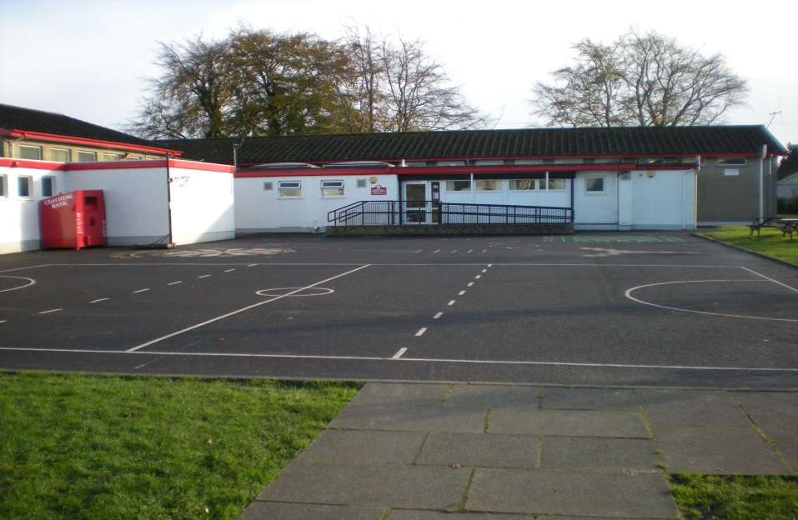

Your Views Count!

Parent Survey 2014

Dear Parents,

I wanted to write to thank all of you who took the time to fill in our recent Parent Questionnaire; your opinions and feedback are extremely important to us. We have been analysing the results and identifying what we can learn from them and how we can use them to further the development of the school. Any good school needs to be constantly looking at itself and reviewing its procedures and your opinions form a fundamental part of that process.

The responses from the parent survey are also available on the school website under ‘Parents; Parent Surveys’. There are a huge number of positives to be taken from the report and this highlights a number of strengths that you feel the school has. The school must, however, learn and listen to areas that you feel could be improved upon and the staff and I will be addressing that in the coming weeks and months.

Finally I would always welcome any feedback about any aspect of school life. Although the official surveys are only once every other year I am always very keen to hear from parents with suggestions for improvement in the way we are operating. Please feel free to contact me at school if you feel you have something to contribute.

With best wishes

Marina McCusker

There were 88 surveys given out and 44 returned.

 | Strongly Agree | Agree | Neither agree nor disagree | Disagree | Strongly Disagree
Well-being

My child enjoys coming to school | 57% | 41% | 2%
My child feels safe and secure in school | 57% | 41% | 2%
The school understands and responds to my child’s needs | 36% | 25% | 7%
My child is encouraged to develop his/ her social and personal qualities | 43% | 52% | 5%
The school encourages my child to reach his/ her potential | 43% | 48% | 9%
My child is valued within the school and their efforts and achievements are celebrated | 41% | 52% | 7%
My child is encouraged to respect and value the opinions/views of others | 41% | 57% | 2%
There is a culture of mutual respect between staff and pupils | 39% | 54% | 7%
My child is encouraged to have a healthy lifestyle | 46% | 52% | 2%
There is a good range of activities including trips or visits for my child to take part in | 46% | 43% | 11%
My child is confident that should they have a problem, there is someone they can go to in school who will listen to them | 30% | 52% | 18%
Learning and Curriculum

My child is encouraged to work hard and do their best | 52% | 41% | 7%
My child finds the work stimulating and interesting | 34% | 52% | 14%
The work my child is asked to do is matched to his/her abilities | 32% | 52% | 14% | 2%
Children who need extra help are identified and well catered for | 34% | 41% | 23% |  | 2%
My child receives an appropriate amount of homework for his/her age | 32% | 48% | 11% | 9%
There are opportunities for extra-curricular activities | 50% | 43% | 7%
The school communicates with me effectively about my child’s progress and I receive helpful information about my child’s progress | 23% | 48% | 20% | 7% | 2%
The school communicates with me effectively about how to support my child’s learning | 25% | 36% | 25% | 9% | 5%
The school communicates with me effectively about school events and activities | 34% | 59% | 7%
The school seeks my views and listens to my concerns | 23% | 41% | 34% | 2%
The school sets high standards for pupils in work and behaviour | 45% | 45% | 10%
The school has a good system to reward good behaviour | 32% | 48% | 20%
Staff deal effectively and fairly with unsatisfactory behaviour | 25% | 50% | 23% | 2%
Communication

As a parent, I feel welcome in the school and there are opportunities to get involved | 41% | 50% | 9%
The school website is useful in providing clear information regarding what has happened in school and also about future events | 23% | 32% | 25% | 5% | 5%
The newsletter provides useful information about school life | 34% | 55% | 11%
I am knowledgeable about the school’s policies and procedures for dealing with child protection matters | 39% | 50% | 11%
I have been informed about the school’s policy on the acceptable use of the internet | 64% | 36%
School Environment

The school building is well maintained | 48% | 45% | 7%
The classrooms are attractive and stimulating reflecting pupils’ work | 48% | 45% | 7%
The school is well thought of in the community | 34% | 57% | 9%
I would recommend Castledawson Primary School to another family | 53% | 45% | 2%
Please indicate by ticking the box
As a parent I would like to know more about:
How the school teaches Reading and Phonics 10%

How the school teaches Mathematics and Numeracy 15%

Ways in which I can help my child with Literacy and Numeracy 24%

Your Additional Comments | Already In Place | Our Future Actions
Communication was poor/ limited | - Dates for diary for year  - Regular September notes and newsletters  - Website updated  - Meet and Greet evening providing information | - Ensure circulation of regular newsletters providing information and website updated  - Ensure parent emails up and running to ensure constant communication  - More use of text to parents service
Healthy Breaks are promoted yet canteen still provides white toast | - Healthy options are available in the canteen in the form of fruit and wheaten bread  - Children have a selection and do not have to choose white bread | - Continue to provide healthy options
There is too much homework / too little homework | - A homework policy is already in place which is available to view on our website. This outlines the different activities and the length of time for each year goup | - We will ensure this is addressed in our School Development Plan as an area for development  - Review Homework Policy and consult with all stakeholders
You would prefer two parent/teacher meetings in year/ more regular reports of progress | - Two parent teacher meetings have been introduced this year (Oct and Feb).  - Annual report in June | - Consider other ways to inform parents of children’s progress on a more regular basis eg. Homework diaries, reading record books, phone call home or a chat about any concerns
Unsure what level your child should be progressing at for their age/ ability |  | - Information sheet of areas covered in Literacy and Numeracy in the year  - Share results of test scores from May with parents in October parent teacher meetings which indicates ability and progress  - Inform parents of children’s targets where applicable  - Information evenings on Literacy and Numeracy to inform parents how to support children at home
Disappointment that children did not receive P7 trip at end of year | - Residential trip introduced for P6/7 to Bushmills | - Annual end of year trips
Some sports not developed eg. hockey | - A lot of sports developed and hockey is proposed for the 3rd term depending on coaches available from Graham Eastwood in Council | - Continue to source coaching for hockey – to confirm a coach with relevant certificate  - Consider local grammar school group coming in to engage children in hockey sessions
More evidence of school rewarding good behaviour | - Star Student of the week  - Certificates  - Goldentime | - We will ensure this is addressed in our School Develop Plan as an area for development  - Review our Positive Behaviour Policy and consult with children through school council  - Consider ways of rewarding good behaviour in all areas of school not just the classroom. Involve children in this process  - Reward children for good character in displaying school values
You were unsure if the School Website was useful in providing clear information regarding school and future events. Not updated regularly. Holiday list would be useful. | - Website has been updated this term and has been on a weekly basis  - All relevant information is on website from calendar dates, diary dates for year, newsletters, after school clubs, class information and other activities | - Ensure website continues to be updated regularly
You were unsure if the school sought and listened to your concerns | - Parent survey given out  - Meet and Greet evening to chat informally and answer any questions  - Parent teacher meetings | - Continue to promote methods already in place and our open door policy
More publicity needed for school | - Use of website and local papers for publicity - upcoming spread in Mid-Ulster Mail and Derry Post  - Hosting Fireworks Display evening for whole community to raise profile of school, photos in Local Women magazine  - School feature in Ulster Tatler  - Develop links with local churches through Christmas Concert and Carol Service  - Develop links with local businesses – Genesis, Moyola Precision Engineering Trips and projects  - Develop links with local schools – Kiddies Kastle invited to events in our school, project with New Row PS  - Open Day with Santa  - PTA events throughout the year  - Community survey to gain feedback from community on our school | - Continue to seek ways of raising profile of school
Unsure whether high standards were set for pupils work | - This is reflected in our school ethos as we encourage children to reach their full potential  - High standards reflected in teaching and learning – success criteria is set along with the children so they know what they are aiming for and understand what ‘good’ looks like  - Pupils are encouraged and shown how to make improvements in their work  - Pupils engage in self assessment where they identify themselves ways in which to improve  - Personal targets are agreed and shared with children to help them achieve high standards | - Become better at informing how to help their child at home to achieve optimum results
Playground has little space | - Two playgrounds for different Key Stages | - Senior playground will have more room when building materials move in October  - Make use of the sports pitch in good weather for extra room
Extra provision in place for children with learning difficulties would be welcome | - Literacy support is available 3 days per week and Numeracy support is available 2 afternoons per week  - Reading Partners Programme offered to children  - Provision available as staffing allows to cater for all children  - Targets in place for underachieving children and Children with SEN. Addressed in class and with outside agencies where appropriate – LTSS, MAST. Speech Therapist, OT | - Catch Up in Numeracy will be available for underachieving children when training is carried out
You were unsure if your child was encouraged to reach their full potential | - This is reflected in our school ethos as we encourage children to reach their full potential – through praise, encouragement, support, challenge  - Various activities in class and after school clubs are offered to ensure we develop the whole child and provide opportunities for each child to experience success in and outside the classroom  - Personal targets are agreed and shared with children to help them reach their full potential
Consider the possibility of text to parents system | - This is a system already in place | - This could be used more regularly where deemed necessary
Children’s achievement outside of school could be celebrated more | - Children’s achievements are celebrated during our Thursday assembly time with whole school and local minister | - Encourage children to share outside achievements  - Promote celebration of outside achievements on our website and through local media
15/44 felt a nursery class would be beneficial, 3/44 felt it wasn’t necessary with the great pre-school facilities in place. |  | - There have been no plans to establish a nursery class. We were measuring a response

